Assignment

Rachit Dani

<https://www.linkedin.com/in/rachitdani/>

rachitdani2014@gmail.com

Objective:

This is an outcome of how the customer success team at Plum is performing on

emails. Column C: Group indicates the different teams at Plum. Share a view on:

a. How are the efficiency numbers looking like? Can you share your views?

b. Which groups are quick, slow etc. Create a table + relevant charts.

c. What type of tickets are taking the most time to resolve? Create a table +

relevant charts.

d. Create the different type of data types we can infer from this data.

**Observation From the data:**

We see the data is arranged in the decreasing order of the number of queries reopens also referring to column D

The Coloumn names :

* Id: Numeric or alphanumeric identifier for each ticket.
* Requester id: Numeric or alphanumeric identifier for the requester of the ticket.
* Group: Categorical data type indicating the different teams at Plum.
* Status: Categorical data type representing the status of the ticket.
* Priority: Categorical data type indicating the priority level of the ticket.
* Via: Categorical data type indicating the channel through which the ticket was received.
* Created at, Updated at, Assigned at, Initially assigned at, Solved at: Temporal data types representing different timestamps.
* Resolution time, Satisfaction Score, Reopens, Replies, First reply time in minutes within business hours, First resolution time in minutes, First resolution time in minutes within business hours, Full resolution time in minutes, Full resolution time in minutes within business hours, Requester wait time in minutes, Requester wait time in minutes within business hours: Numeric data types representing various durations or scores.
* Manual Tagging of Categories: Categorical data type representing manually assigned tags or categories associated with the tickets.

**Clean the data**

Removing the irrelevant coloumns and duplicate values from our analysis

There were a few blank values and irrelvent coloumns like updated at,assigned at ,initially assigned at

Filling blank values with means of their respective columns

**Analyzing the data:**

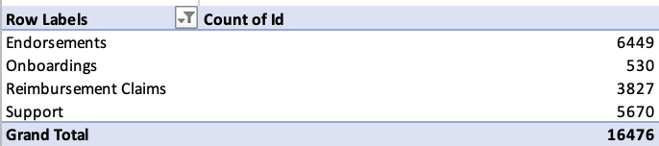

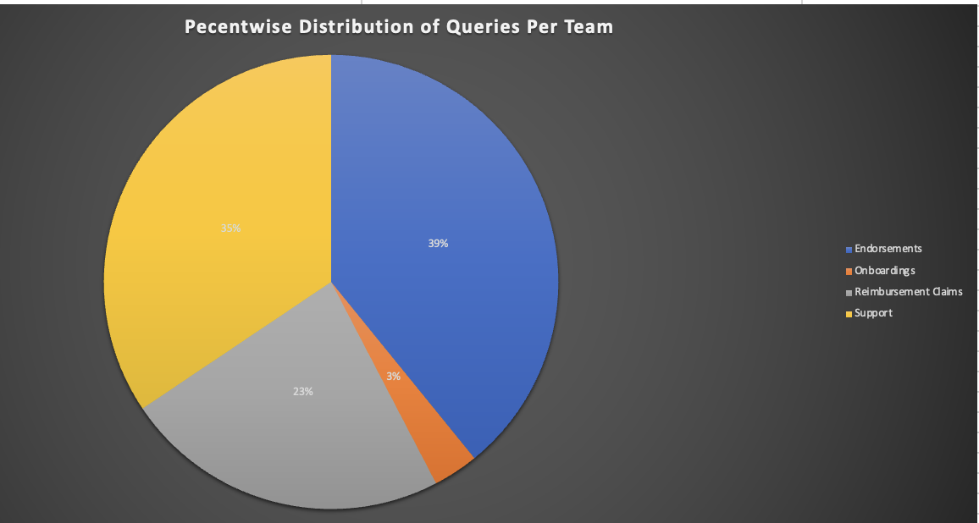

This gives us the info of the detailed distribution of queries received per Team in both the number of queries and the percentage distribution compared to the others. Tells us that the maximum queries are for the endorsements team followed by the support team

About 39% of the queries are for the endorsements and 35% are for support and the least for the onboarding team

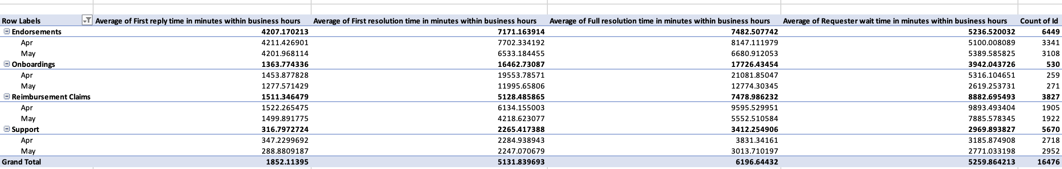

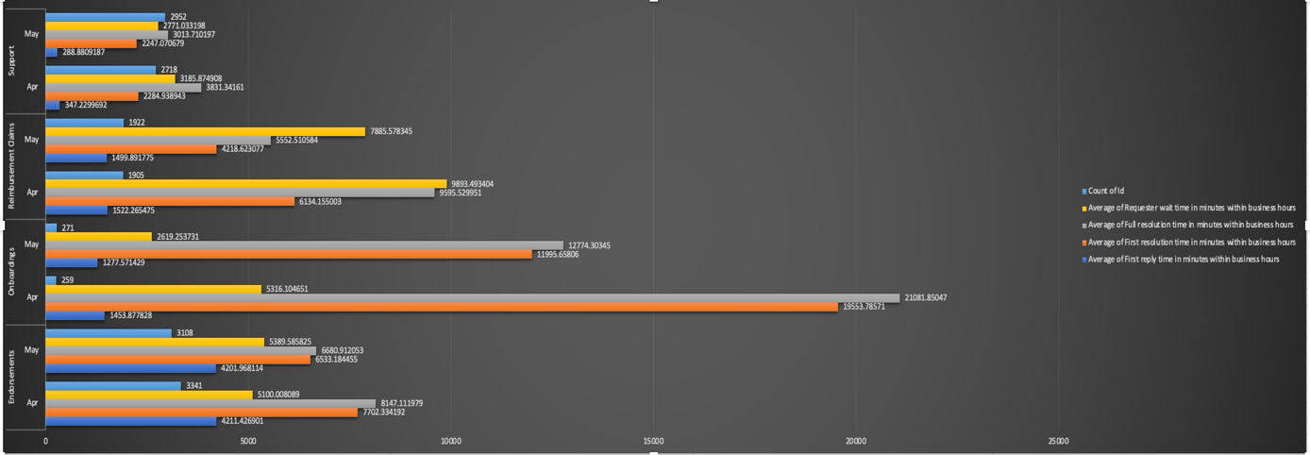

This tells us the monthly change during the business hours the average requester wait time,first resolution ,first reply,full resolution time and also displaying the count of the queries.

The efficiency Calculation:

* Average Response Time: Calculate the average time taken by each group to respond to tickets. This is computed by finding the mean of the "First reply time in minutes within business hours" column for each group.
* Average Resolution Time: Calculate the average time taken by each group to resolve tickets. This is computed by finding the mean of the "Full resolution time in minutes within business hours" column for each group.

From this we can obtain that despite the number of queries the support team is very efficient in replying during business hours making the entire resolving process as quick as possible .

Comparing Month on Month basis despite the number of queries being same the Reimbursement Claims Team and Onboarding team proved to be inefficient as the waiting time and resolution time increased drastically during the business hours.

And overall, all the teams proved to be more efficient during the business hours in the month of May compared to June

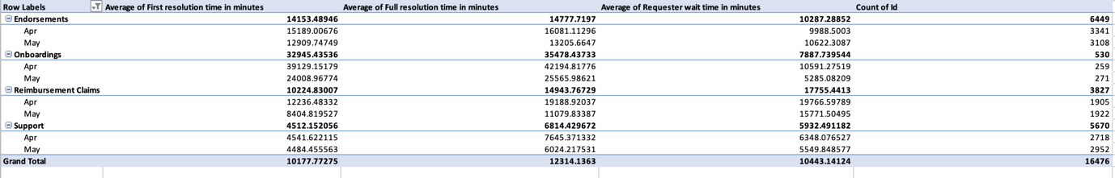

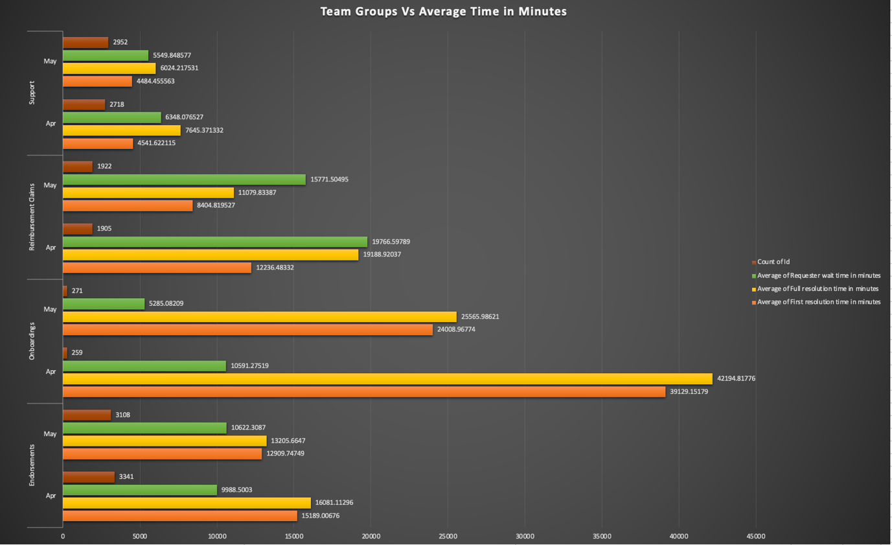

The average requester wait time reduced only in the endorsements compared to all the other teams despite the number of queries becoming more and others number of queries were almost similar.

The onboarding teams must be given more team members as their query related work is very inefficient.

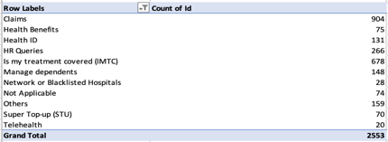

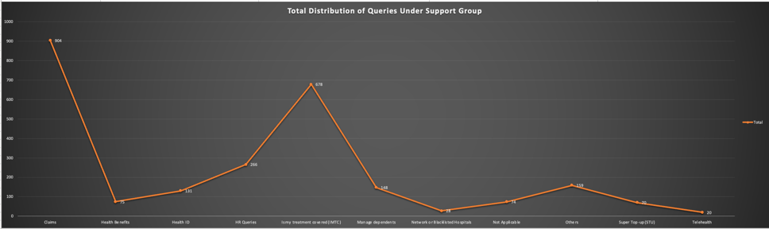

Under support group maximum queries are for the claiming purpose which is about 35% of the queries followed by the is my treatment covered accounting to 23% of the queries

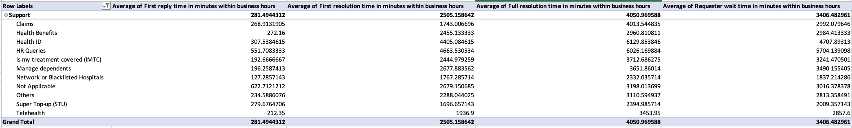

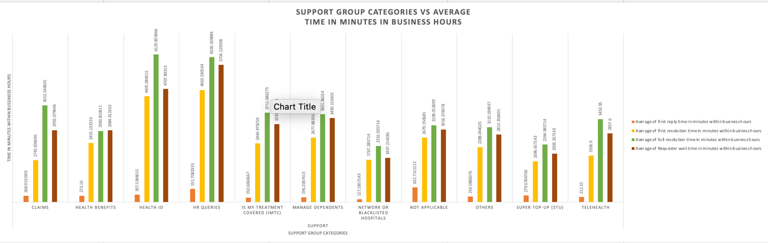

Under the support queries the not applicable and hr queries take the maximum time for the first reply which is about 180% more compared to the other sub categories

The Health Id and HR queries take the maximum time for full resolution under the support subcategory during the business hours which is about 6000 mins which is 25% more compared to the overall average of the resolution by the support group during business hours

The requester wait time is approx. 40% more in the hr queries compared to the other subgroups of support category during business hours.

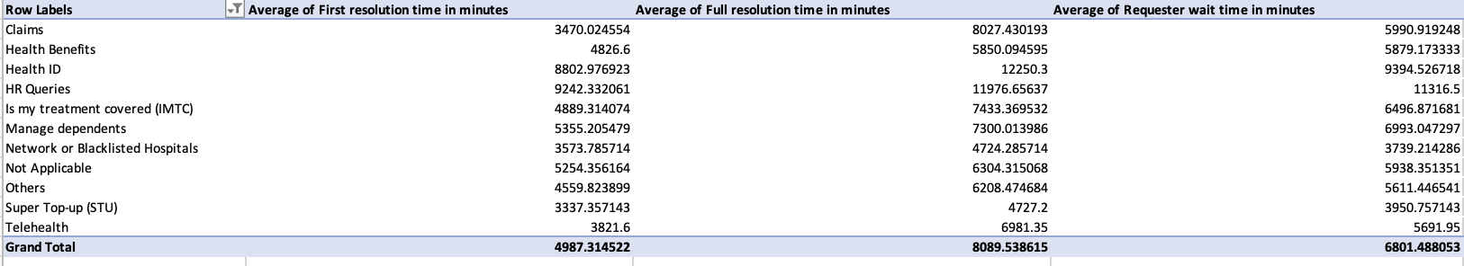

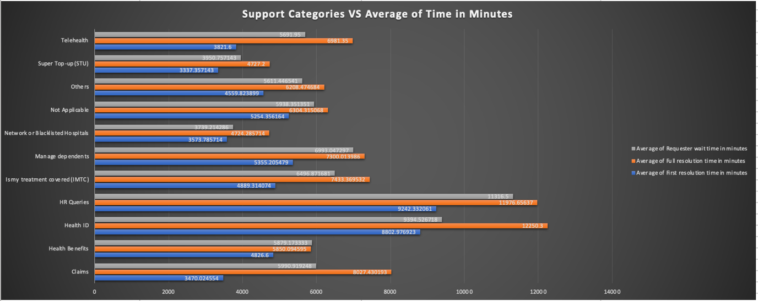

The average requestor wait time is 6801 minutes in total per query raised and to obtain the first resolution is 4987 minutes and to get the complete resolution it is around 8089 minutes from the time of the ticket raised.

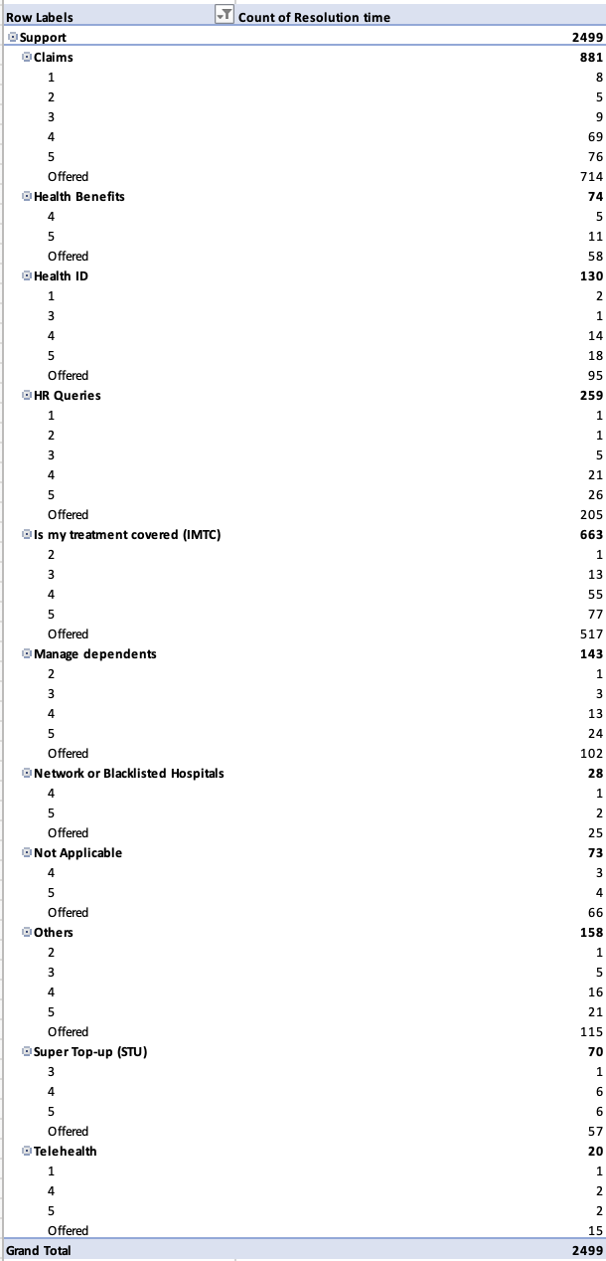

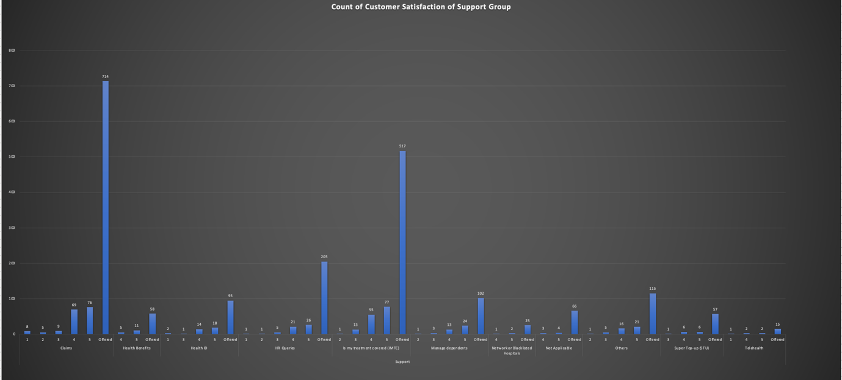

The maximum people are satisfied with the support offered by the support group only about 11% of the people are not satisfied with the response obtained which tells that the support group is providing very good customer satisfaction

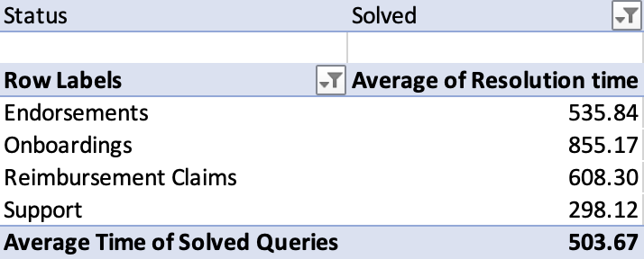 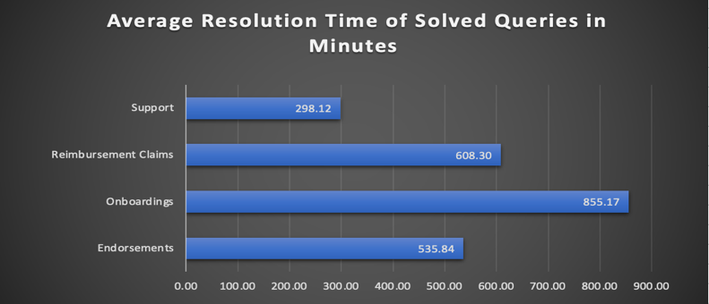

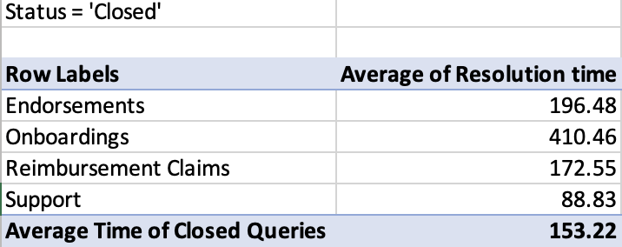 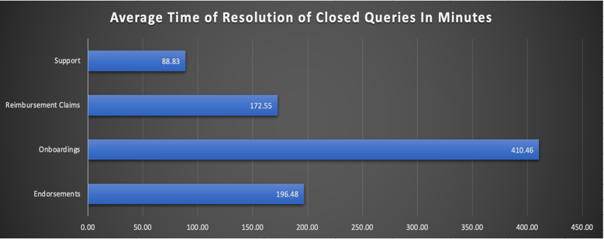

The average Resolution time for the closed tickets is 70% less compared to the solved tickets

The support group has an average resolution time of 89 minutes for closed queries whereas 298 minutes for the solved queries

The Reimbusment group has an average resolution time of 172.5 minutes for closed queries whereas 608 minutes for the solved queries

The onboarding group has an average resolution time of 410.5 minutes for closed queries whereas 855 minutes for the solved queries which a

The endorsements group has an average resolution time of 198.5 minutes for closed queries whereas 536 minutes for the solved queries

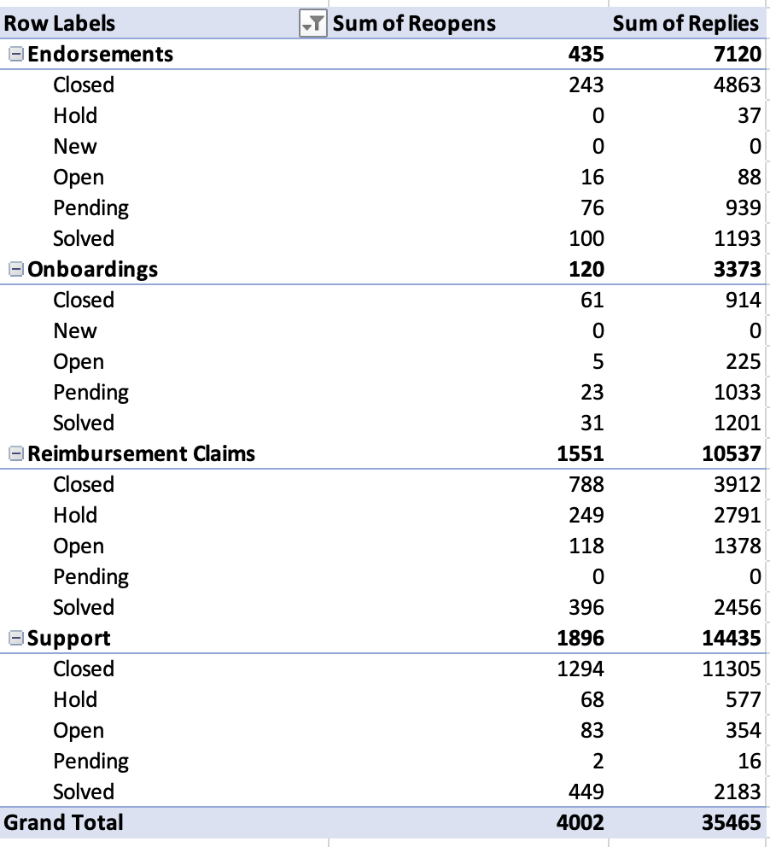

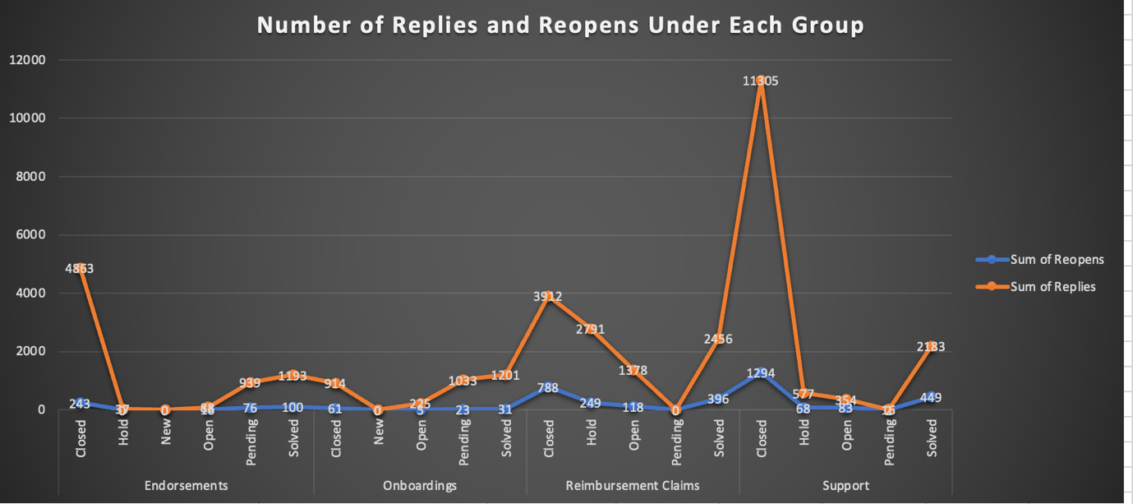

The number of reopens is maximum for closed support queries which is 1294 which is 32% of the query reopening’s done

The maximum replies is by the closed support group queries which is 11305 followed by the closed endorsements group which is 4863

The pending reply queries are maximum for the onboardings team 1033 followed by the endorsements group accounting to 939

The reimbursement claims group are proved to be most active because they have 0 pending queries and the support group also has negligible pending queries about 2

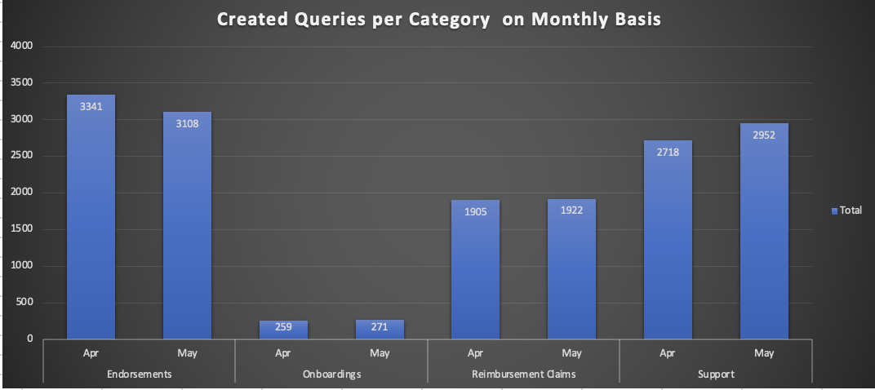

We can observe that the number of queries under each group has almost negligible changes on Month-to-Month basis.

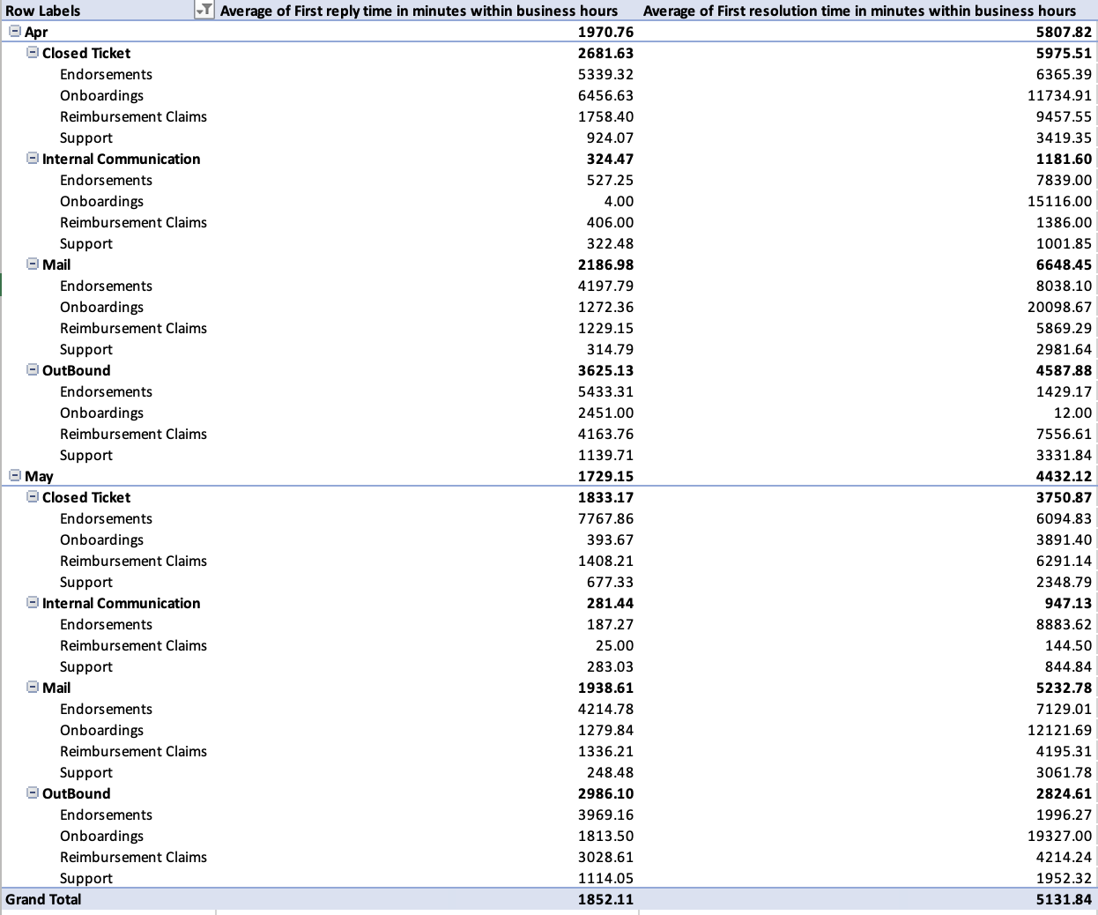

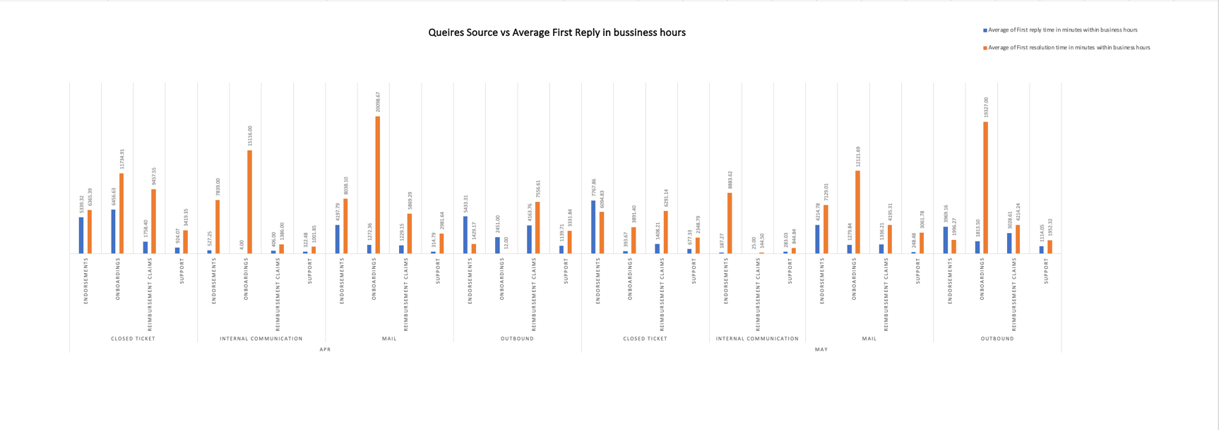

In April,The comparison on the Source of queries the difference between reply and resolution time during business hours is maximum by the onboarding team for the query received by mail.

In May , The comparison on the Source of queries the difference between reply and resolution time during business hours is maximum by the onboarding team for the queries via outbound

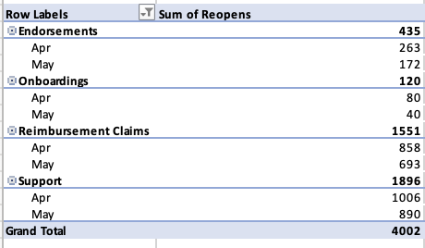

The number of reopens between queries by all the teams reduced compared to the previous month this tells us that the queries are taking longer time to resolve but the outcome is satisfaction which is resulting in less reopens

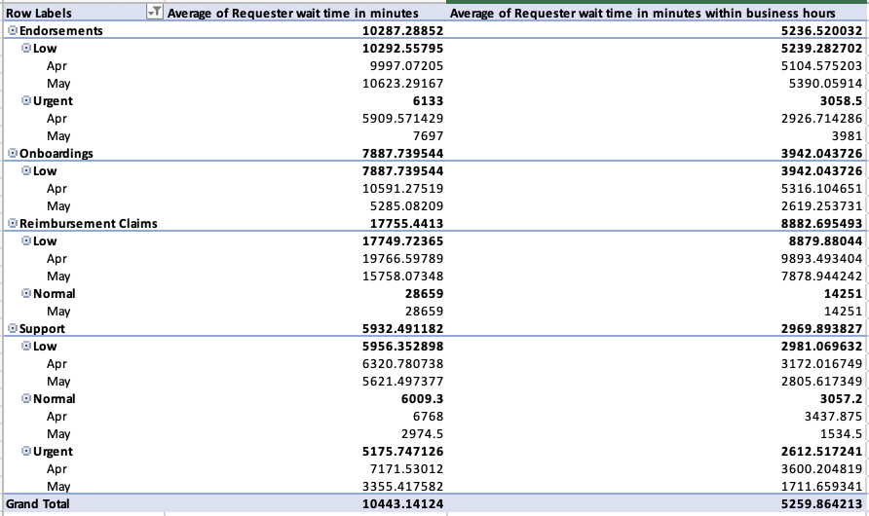

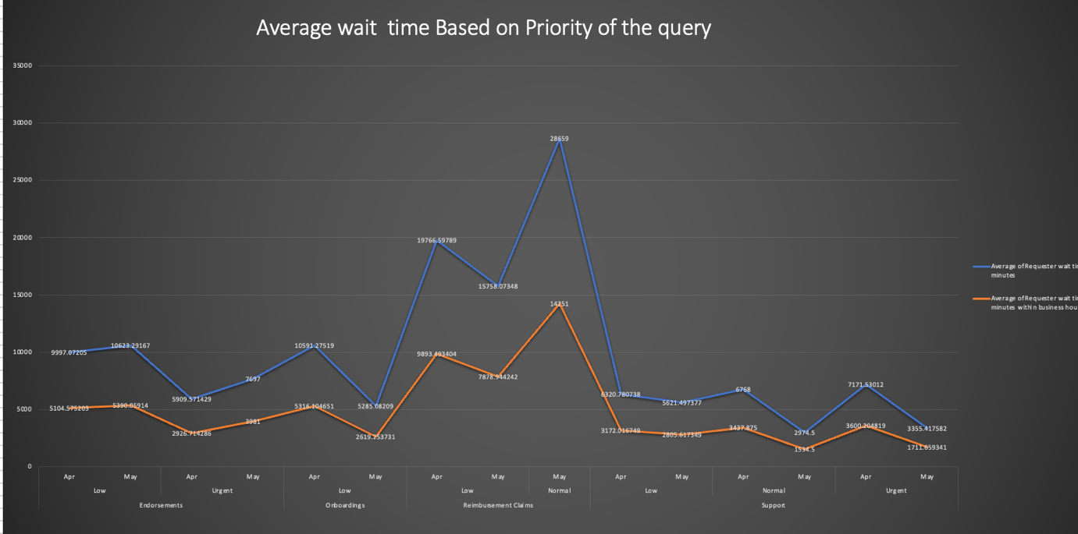

The average waiting time for the low priority queries related to onboarding time is reduced by 50 % from April to May ,Whereas the waiting time for Urgent priority queries related to the endorsements group is raised by 25% compared to May and the normal and urgent priority waiting time has been reduced by about 50% compared to the previous month

Insights:

* About 39% of the queries are for the endorsements and 35% are for support and the least for the onboarding team which tells us that these two groups should have maximum number of representatives for management
* Despite the number of queries the support team is very efficient in replying during business hours making the entire resolving process as quick as possible and the group is currently best optimised and proving to be effifcient.
* The onboarding teams must be given more team members as their query related work is very inefficient.
* And overall, all the teams proved to be more efficient during the business hours in the month of May compared to June
* Under support group maximum queries are for the claiming purpose which is about 35% of the queries followed by the is my treatment covered accounting to 23% of the queries
* The Health Id and HR queries take the maximum time for full resolution under the support subcategory during the business hours which is about 6000 mins which is 25% more compared to the overall average of the resolution by the support group during business hours
* The average requestor wait time is 6801 minutes in total per query raised and to obtain the first resolution is 4987 minutes and to get the complete resolution it is around 8089 minutes from the time of the ticket raised.
* The maximum people are satisfied with the support offered by the support group only about 11% of the people are not satisfied with the response obtained which tells that the support group is providing very good customer satisfaction
* The average Resolution time for the closed tickets is 70% less compared to the solved tickets
* We can observe that the number of queries under each group has almost negligible changes on Month-to-Month basis.
* The number of reopens between queries by all the teams reduced compared to the previous month this tells us that the queries are taking longer time to resolve but the outcome is satisfaction which is resulting in less reopens
* In April,The comparison on the Source of queries the difference between reply and resolution time during business hours is maximum by the onboarding team for the query received by mail.
* In May , The comparison on the Source of queries the difference between reply and resolution time during business hours is maximum by the onboarding team for the queries via outbound
* The average waiting time for the low priority queries related to onboarding time is reduced by 50 % from April to May ,Whereas the waiting time for Urgent priority queries related to the endorsements group is raised by 25% compared to May and the normal and urgent priority waiting time has been reduced by about 50% compared to the previous month